**Project Design Phase-II**

**Functional Requirements & Data Flow Diagram**

|  |  |
| --- | --- |
| Date | 08 October 2022 |
| Team ID | PNT2022TMID04383 |
| Project Name | Real-Time Communication System Powered by AI for Specially Abled |
| Maximum Marks | 4 Marks |

**Functional Requirements:**

Following are the functional requirements of the proposed solution.

|  |  |  |
| --- | --- | --- |
| **FR No.** | **Functional Requirement (Epic)** | **Sub Requirement (Story / Sub-Task)** |
| FR-1 | User communication | User Must Known the Sign Language |
| FR-2 | User communication | User Has to communicate in Front of Camera |

**Data Flow Diagrams:**

A Data Flow Diagram (DFD) is a traditional visual representation of the information flows within a system. A neat and clear DFD can depict the right amount of the system requirement graphically. It shows how data enters and leaves the system, what changes the information, and where data is stored.

FLOW:

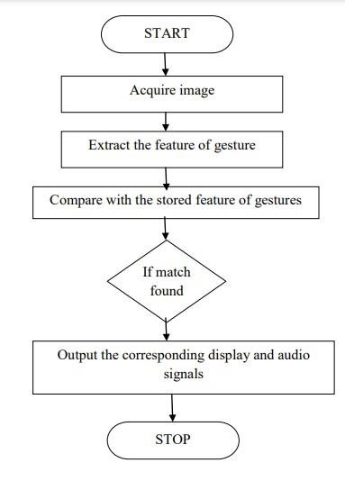

* We begin with gathering essential information from mediapipe comprehensive and get a lot of information from keypoints.
* Store information as numpy arrays.
* Then, using the data that we have already stored, we create an LSTM model.
* We choose the number of epochs for the model; as the number of epochs increases, accuracy rises, but so does computation time, and overfitting of the model for gesture recognition is possible.